**CHAPTER 1: INTRODUCTION**

**1.1 Overview**

E-learning is an education via the Internet, network, or standalone computer. E-learning is basically the network- enabled convey of skills and knowledge. E-learning refers to using electronic applications and processes to learn. E-learning includes all forms of electronically supported learning and teaching (Trikes, G,2010).The information and communication systems, whether networked learning or not, serve as specific media to implement the learning process. This often involves both out-of-classroom and in- classroom educational experiences via technology, even as advances continue in regard to devices and curriculum. E-learning is the computer and network-enabled transfer of skills and knowledge. E-learning applications and processes include Web-based learning, computer-based learning, virtual education opportunities and digital collaboration. Content is delivered via the Internet, intranet/extranet, audio or video tape, satellite TV, and CD-ROM. That is to say E-learning systems contain both Learning Management System and Course management system. It can be self-pace or instructor-led and includes media in the form of text, image, animation, streaming video and audio. It is commonly thought that new technologies can make a big difference in education. In young ages especially, children can use the huge interactivity of new media, and develop their skills, knowledge, and perception of the world, un under their parents' monitoring, of course. With the increasing adoption of the Internet and rise in awareness about e-learning, the online education industry is expected to witness promising growth during the forecast period. Ease of learning, flexibility, and a wide range of study materials have influenced the overall growth of the industry. The online education market is segmented into primary and secondary supplemental education, test preparation, reskilling and certification, higher education language, and casual learning. The change in consumer behavior towards detailed learning and surge in demand fromtier II and tier III cities are driving the growth of this segment. The online test preparation market is expected to reach INR 94.75 Bn by 2024. This segment is expected to be the fastest-growing segment in the online education market.

E- Learning education is an electronically supported learning system, which relies on the Internet for interaction and distribution of course material between students and teachers. Growing demand to reduce the cost of education, increasing government initiatives supporting online education, and increasing penetration of smartphones and the Internet are the factors contributing to the growth of the global online education market. Additionally, the market is also expected to be boosted owing to the increasing demand for adaptive learning. However, the availability of abundant free content and lack of awareness is limiting the market growth. Many proponents of e-learning believe that everyone must be equipped with basic knowledge In Technology, as well as use it as a medium to reach a particular goal and aim. In the 20thcentury, we have moved from the Industrial Age through the Information Age and now to the Knowledge Age. Knowledge and its efficient management constitute the key to success and survival for organizations in the highly dynamic and competitive world of today. Efficient acquisition, storage, transfer, retrieval, application, and visualization of knowledge often distinguish successful organizations from the unsuccessful ones. E-learning is bridging the gap between learning and work. Workers can integrate learning into work more effectively because they use the same tools and technology for learning as they use for work. Both employers and employees recognize that e-learning will diminish the narrowing gap between work and home, and between work and learning. E-learning is an option to any organization looking to improve the skills and capacity of its employees. With the rapid change in all types of working environments, especially medical and healthcare environments, there is a constant need to rapidly train and retrain people in new technologies, products, and services found within the environment. There is also a constant and unrelenting need for appropriate management and leveraging of the knowledge base so that it is readily available and accessible to all stakeholders with in the work place environment.

**1.2 Advantages**

**1. Informative Platform for Educational Institutes**

A website is a platform where anyone can have access. They could search for anything they want about the institute from the websites. Anyone can have full information. Because of that they would be well informed of all the important dates and notifications. No need to go to the institute physically. That way your educational institute won’t be limited in its geographical boundary. From your website, the viewers would get the full idea of the details of your institute. They would know about the courses, faculties, events, services. Even you could use your website to share the study materials for distance learning students.

**2. Grow Interest Through Your Educational Website**

The design of your website should grow interested in the viewers. Using infographics, typographic and color imagery could catch the attention of the respective audience. Through these, you could tell your viewers what courses and services you are offering. You should use high-quality pictures because a picture tells a story through it.

**3. Use Video Content**

Today’s generation is very much attracted to the videos. They will understand things or give it more time if you present them with video content. You could upload the videos of lectures, events, tutorials, course-related interactive videos or simply the promotional videos will also grab the attention.

**4. Enriched Content for Your Educational Website**

Be sure to satisfy the quarries of your audience. Representing an educational institute means you need to be all aware of your field. As you are in the educational department, you might already know that. Through your web content, the students and their parents will judge you and make their decisions. So, it is your chance to catch their attention.

**5. Be Responsive**

You could provide the services of online tutorial through your website. If any of your students have any questions regarding their subjects, through the website they should be able to solve it. In this era of the internet, you should make sure that you reach as much devise as possible. That way you would be available all the for your students.

**6. Use Educational Website for Marketing**

Though the events will take place in your institute’s campus, you could always share the information through your website. Let your audience know all that was happening in your institute. You could also tell them about the ceremonies, award functions, events, results and success of your students, extracurricular achievements, etc. of your institution.

It could be said that by educational website development you could achieve more than limiting yourself in the geographical boundary. But now the question is who would be the right choice to assist you to reach your goal. After this long journey let me help you some more by suggesting one of the best.

**1.3 Introduction of Project**

Education System Website is the delivery of learning and training through digital resources. Although Groove is based on formalized learning, it is provided through electronic devices such as computers, tablets and even cellular phones that are connected to the internet. This makes it easy for users to learn anytime, anywhere, with few, if any, restrictions. Basically, Education System Website is training, learning, or education delivered online through a computer or any other digital device. Education System Website is an online platform developed for the purpose of live coaching. It facilitates live coaching classes for 1th to 10th-grade students. The platform is also dedicated to the training for several Courses such as the Machine Learning, Programming Languages, Video Editing etc. To offer its support to the 21st century’s education system, the platform allows LIVE interactive online learning amidst the pupils and teachers. It also offers individual as well as group classes. The platform makes use of two-way audio, video as well as whiteboarding tools which enables both the student as well as the teacher to view, listen, write as well as interact in real-time.

**1.4 Aim and Objective of Project**

The objective of an educational website can vary depending on the specific goals and target audience. Here are some common objectives that educational websites often aim to achieve:

**1. Dissemination of Information:** Provide a platform for the efficient and organized delivery of educational content, resources, and information to a wide audience.

**2.Accessibility:** Ensure that educational resources are accessible to a diverse audience, including individuals with different learning styles, abilities, and backgrounds.

**3. Skill Development:** Support the development of skills and competencies by offering courses, workshops, and training materials that align with the needs of the target audience.

**4. Community Building:** Foster a sense of community among learners, educators, and other stakeholders by providing forums, discussion boards, or social media integration to facilitate collaboration and knowledge-sharing.

**5. User Engagement:** Create an engaging and user-friendly interface to keep learners motivated and interested in the educational materials. This may include the use of multimedia, gamification, and other interactive elements.

**6. Assessment and Feedback:** Implement assessment tools, quizzes, and feedback mechanisms to evaluate learner progress and provide constructive feedback for improvement.

**7. Resource Centralization:** Act as a central hub for educational resources, bringing together materials from various sources to make learning more convenient for users.

**8. Adaptability:** Design the website to be adaptable to different learning environments, including formal education, self-paced learning, and professional development.

**9. Promotion of Lifelong Learning:** Encourage a culture of lifelong learning by providing resources that cater to learners of all ages and backgrounds.

**10. Continuous Improvement:** Collect and analyze data on user interactions and learning outcomes to continually improve and update the content and features of the educational website.

It’s essential to tailor the objectives based on the specific mission and vision of the educational website, as well as the needs of the target audience.

**1.5 Purpose**

The purpose of an educational website is multifaceted, encompassing various goals and objectives aimed at facilitating learning, disseminating information, and fostering a positive educational experience. Here are some key purposes of an educational website:

**1. Accessible Learning Resources:** Provide a platform for easy access to educational content, resources, and materials, making learning more convenient for a diverse audience.

**2. Global Reach:** Extend the reach of education beyond geographical boundaries, allowing individuals from different locations to access quality educational materials and opportunities.

**3. Flexible Learning Opportunities:** Offer flexibility in learning by providing self-paced courses, on-demand resources, and materials that cater to different learning styles and schedules.

**4. Skill Development:** Support the development of various skills and competencies, including academic, professional, and personal skills, through targeted courses and resources.

**5. Supplementary Learning:** Serve as a supplementary resource to formal education, providing additional materials, explanations, and examples to reinforce classroom learning.

**6. Lifelong Learning:** Encourage a culture of lifelong learning by offering resources that cater to learners of all ages and backgrounds, promoting continuous personal and professional development.

**7. Interactive Learning:** Foster engagement and interactivity through the use of multimedia, simulations, quizzes, and other interactive tools to enhance the learning experience.

**8. Collaboration and Community:** Facilitate collaboration and knowledge-sharing among learners, educators, and experts through discussion forums, social media integration, and collaborative projects.

**9. Professional Development:** Provide resources and courses that contribute to the professional development of individuals, helping them stay current with industry trends and advancements. **10. Career Guidance:** Offer information and resources related to career paths, job opportunities, and industry insights to assist learners in making informed decisions about their future.

The overall purpose of an educational website is to contribute to the development and enrichment of individuals through accessible, engaging, and effective learning experiences. Whether used as a supplement to formal education or as a standalone learning platform, educational websites play a crucial role in democratizing education and promoting knowledge dissemination on a global scale.

**1.6 Scope**

The scope of an educational website project encompasses all the features, functionalities, and content that the website will include to achieve its objectives. The scope defines the boundaries and parameters of the project, outlining what will and will not be included.

1. **Content Development:**

• Define the types of educational content to be included (e.g., text-based articles, videos, interactive simulations, quizzes).

• Determine the subjects or topics that the content will cover.

• Specify whether the content will be created in-house or sourced from external providers.

**2. User Features:**

• Identify user roles (students, teachers, administrators) and determine their respective privileges and access levels.

• Specify user authentication and authorization mechanisms.

• Define user engagement features, such as discussion forums, chat functionality, and collaborative tools.

1. **Learning Management System (LMS):**

• Decide whether the website will have a Learning Management System for course creation, enrollment, tracking progress, and managing assessments.

• Outline the features of the LMS, such as course organization, grading, and reporting.

1. **Interactive Tools:**

• Determine if the website will include interactive tools, such as virtual labs, simulations, or educational games. • Specify the technology required to implement these interactive elements.

1. **Assessment and Feedback:**

• Define the assessment methods (quizzes, exams, projects) and feedback mechanisms.

• Outline how progress will be tracked and communicated to learners.

1. **Community and Collaboration:**

• Specify features that support community building, such as discussion forums, social media integration, or collaborative projects.

• Determine moderation and administration tools for community interactions.

1. **Mobile Responsiveness:**

• Decide if the website will be accessible and usable on various devices, including mobile phones and tablets.

• Specify the design and functionality considerations for different screen sizes.

**CHAPTER 2: ANALYSIS AND SYSTEM REQUIREMENTS**

**2.1 The Current System**

The current situation is very limited to few resources, students are unable to get knowledge more than that the lecture provides to them. This in the end limits student’s performances, because everything a student gets is collected from lectures in class. Here are some of the problems of the current system:

* Students submit assignment to lectures through hard copies or personal emails.
* Students only get help from lectures if the lectures are in their office.
* New lectures to a course have to get materials on their own.
* Student are required to physical be in the classroom in order to gain knowledge there by sacrificing all other responsibilities.
* Students are unable to share resources effectively and hold group discussions that are monitored or supervised by lectures

**2.2 The Future System**

The system will hopefully serve as a centralized database of syllabus for the courses offered at the university allowing students and faculties (current, past and prospective), to view them. The

System will end up bringing an effective communication among students, lectures and the administration, by accessing system information and other resources anytime, anywhere. Here are some expected results of the project:

* Lectures to upload assignments and resources for their units.
* Students to download the resources and upload assignments.
* It provides an easy-to-use way to manage course websites that include schedule information, announcements, as well as course discussions.

**2.3 Software Requirement:**

Software requirements define the functionalities, constraints, and qualities that a software system must exhibit. They serve as a foundation for the development process, guiding the design, implementation, and testing phases. These requirements can include features, performance expectations, user interactions, and system constraints, providing a clear roadmap for the development team to follow. The software requirements for an educational website typically encompass a range of features and functionalities to support effective learning and user interaction.

Here are some common software requirements for an educational website:

1. **User Authentication:**

• Secure user login and registration processes.

• Password recovery mechanisms.

1. **User Roles:**

• Differentiate between roles such as students, teachers, and administrators.

• Role-specific permissions and access levels.

1. **Course Management:**

• Ability to create, edit, and manage courses.

• Support for multimedia content, assignments, and assessments.

1. **User Profiles:**

• Personalized profiles for students and teachers.

• Tracking progress and achievements.

1. **Content Management:**

• Upload and organize educational content such as lectures, documents, and multimedia. • Support for different file formats.

|  |  |
| --- | --- |
| Name of component | Specification |
| Operating System | Windows 10 |
| Language | HTML,CSS,JavaScript |
| Browser | Chrome |
| Scripting language enable | JavaScript |

**WINDOWS 10:** Windows 10 is a widely used operating system developed by Microsoft. It is the successor to Windows 8.1 and was released in July 2015. Windows 10 is designed to work across a variety of devices, including PCs, tablets, smartphones, and embedded systems. It introduced several new features compared to its predecessors, such as the Cortana virtual assistant, the Microsoft Edge web browser, a revamped Start menu, and the ability to run Universal Windows Platform apps that can adapt to different device types. Windows 10 also includes regular updates and security patches to improve performance and address potential vulnerabilities. Windows 10 has been well-received for its user interface improvements, performance enhancements, and focus on modern computing trends. It is widely used by consumers, businesses, and organizations around the world.

**HTML:** HTML, which stands for HyperText Markup Language, is the standard markup language used to create web pages. It is the basic building block of web development and is used to structure content on the web, such as text, images, videos, and links. HTML uses a system of tags to define the structure and layout of a web page, with each tag representing different elements like headings, paragraphs, lists, links, and more. HTML documents are interpreted by web browsers to render the content and display it to users. Along with CSS (Cascading Style Sheets) for styling and JavaScript for interactivity, HTML forms the core technologies used to create websites and web applications. It provides a set of tags that structure the content and layout of a web page, allowing developers to define headings, paragraphs, lists, links, images, and other elements. HTML documents are interpreted by web browsers to display the content to users. **CSS:** CSS, which stands for Cascading Style Sheets, is a style sheet language used to describe the presentation of a document written in HTML or XML (including XML dialects such as SVG or XHTML). It defines how elements are displayed on a screen, in print, or in other media. CSS separates the content of a web page (defined in HTML) from its presentation, allowing developers to control the layout, colors, fonts, and other visual aspects of a website. CSS works by selecting HTML elements and applying style properties to them. For example, you can use CSS to set the color and size of text, define the layout of a page, create animations, and make the website responsive to different screen sizes. CSS is an essential part of web development and is used alongside HTML and JavaScript to create visually appealing and interactive web pages.

**JAVASCRIPT:** JavaScript is a high-level programming language that is primarily used to create interactive effects within web browsers. It is one of the core technologies of the World Wide Web, along with HTML and CSS. JavaScript allows developers to add dynamic behavior to their websites, such as responding to user actions, manipulating the DOM (Document Object Model), and making asynchronous requests to web servers. Key features of JavaScript include: 1. Client-Side Scripting: JavaScript code is executed on the client's browser, which allows for dynamic content generation and manipulation without requiring server interaction. 2. Object-Oriented: JavaScript is an object-oriented language, which means it uses objects and their properties and methods to organize code. 3. Event-Driven: JavaScript is often used to create event-driven applications, where code is executed in response to certain events, such as a user clicking a button or submitting a form. 4. Asynchronous Programming: JavaScript supports asynchronous programming through features like callbacks, promises, and async/await, allowing developers to write non-blocking code that can handle multiple operations simultaneously. 5. Cross-Platform: JavaScript is supported by all major web browsers, making it a crossplatform language for web development. JavaScript is a versatile language that is not only used for web development but also for server-side development (Node.js), mobile app development (React Native, Ionic), game development, and more.

**CHROME:** Chrome, short for Google Chrome, is a popular web browser developed by Google. It was first released in 2008 and has since become one of the most widely used web browsers, competing with other major browsers like Mozilla Firefox, Microsoft Edge, and Apple Safari. Key features of Google Chrome include: 1. Speed and Performance: Chrome is known for its fast performance, quick startup times, and efficient use of system resources. 2. Synchronization: Chrome allows users to sign in with a Google account, which enables synchronization of bookmarks, history, and settings across multiple devices. 3. Security: Chrome includes built-in features such as Safe Browsing, which helps protect users from phishing and malware, as well as automatic updates to ensure users have the latest security patches. 4. Customization: Chrome supports a wide range of extensions and themes, allowing users to customize their browsing experience with additional features and visual changes. 5. Developer Tools: Chrome includes powerful developer tools that help web developers debug and profile their web applications, inspect HTML and CSS, and analyze network performance. 6. Cross-Platform: Chrome is available on multiple platforms, including Windows, macOS, Linux, Android, and iOS, providing a consistent browsing experience across devices. Google Chrome has a large market share in the web browser market due to its speed, simplicity, and integration with other Google services. It is also known for its support of modern web standards and its focus on providing a secure and stable browsing experience.

**2.4 Hardware Requirement:**

The hardware requirements for an educational website depend on factors such as the anticipated traffic, content complexity, and functionality. Generally, you'll need:

• **Web Server:** A powerful server to host and serve web pages efficiently. Consider factors like processor speed, RAM, and storage capacity based on expected traffic.

• **Database Server:** If your website involves user accounts, courses, or other dynamic content, a robust database server is essential. MySQL, PostgreSQL, or similar databases are common choices.

• **Storage:** Ensure sufficient storage for website files, multimedia content, and database storage. SSDs can improve data retrieval speed.

• **Memory (RAM):** Sufficient RAM is crucial for smooth performance, especially if your website deals with concurrent users or resource-intensive operations.

• **Network Infrastructure:** A reliable and high-speed internet connection to handle user requests and data transfers efficiently.

• **Load Balancer:** For scalability and distribution of incoming traffic across multiple servers, especially if your website grows in popularity.

• **Backup Systems:** Implement regular backups to prevent data loss in case of server failures or other issues. • Security Measures: Firewalls, SSL certificates, and other security protocols to safeguard user data and protect against cyber threats.

• **Content Delivery Network (CDN):** To optimize content delivery, especially if your audience is distributed globally. It's essential to scale your hardware based on your website's growth and user demands. Regular monitoring and performance optimization are key to maintaining a reliable educational website.

|  |  |
| --- | --- |
| Name of component | Specification |
| Processor | Intel Core i5 10th Gen |
| RAM | 128 MB |
| Hard Disk | 15’’ color monitor |
| Keyboards | 122 keys |

**CHAPTER 3 : SYSTEM DESIGN**

**3.1 UML Diagram**

A UML (Unified Modeling Language) diagram is a visual representation tool used in software engineering to model and design systems effectively. It helps illustrate different aspects of a system, such as structure, behavior, and interactions, making it easier for developers to understand and communicate the system’s architecture and functionality. UML diagrams come in various types, including class diagrams for displaying system structure, use case diagrams to show user interactions, sequence diagrams to model object interactions over time, and activity diagrams for workflow processes. Each type of diagram has its unique focus but together provides a comprehensive view of the system. UML diagrams are particularly valuable in complex projects because they help break down the system’s components and their relationships, allowing for clear planning and documentation that supports development, testing, and future maintenance.

**3.1.1 Use Case Diagram**

A **Use Case Diagram** is a type of UML diagram that visually represents the functional requirements of a system from the user's perspective. It highlights the different ways a user (or "actor") interacts with the system to accomplish specific goals or tasks. Use case diagrams are commonly used during the planning phase of software development to help identify key functionalities and the relationships between users and system processes.

**Key Components of a Use Case Diagram:**

1. **Actors**: Represent users or external systems that interact with the system. They can be people (like "Student" or "Admin") or other systems (like "Payment Gateway").
2. **Use Cases**: Depict the functions or actions performed by the system to achieve a specific outcome. Examples might include "Login," "Enroll in Course," "Submit Quiz," or "Generate Report."
3. **System Boundary**: Defines the scope of the system and distinguishes what is inside (controlled by the system) from what is outside.
4. **Relationships**:
   * **Association**: Shows that an actor participates in a use case.
   * **Include**: Indicates that one use case uses another use case’s functionality (e.g., "Enroll in Course" includes "Login").
   * **Extend**: Represents an optional use case that extends the functionality of another use case.

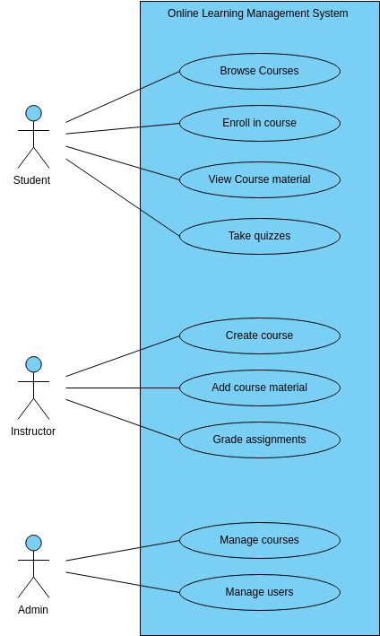

Figure 3.1.1-Use Case Diagram

**3.2 Data Flow Diagram**

A Data Flow Diagram (DFD) is a visual representation used to map out the flow of data within a system, showing how inputs are processed and transformed into outputs. It illustrates the interaction between external entities (like users or other systems), processes, data stores, and data flows. DFDs are structured in layers, with the Context Diagram providing a high-level view of the system and its interaction with external entities, while Level 1 and subsequent diagrams break down processes into more detailed sub-processes. This helps to visualize how data moves through the system, what processes handle it, and where it is stored, offering insights into system functionality, data relationships, and potential bottlenecks. DFDs are widely used in system analysis and design for understanding data handling and ensuring smooth information flow across components.

**3.2.1 Level 1 DFD**

A Level 1 Data Flow Diagram (DFD) is a more detailed version of the Context Diagram. It breaks down the single high-level process into sub-processes, providing a clearer picture of how data flows through the system at a granular level. While the Context Diagram shows only the system as one process and its interactions with external entities, a Level 1 DFD reveals the core functions of the system, the data stores, and how data is processed and transferred between them.

**Key Features of a Level 1 DFD:**

1. **Processes:** The main process from the context diagram is broken down into smaller, detailed processes. Each process represents a function or activity that transforms input data into output.
2. **Data Flows:** Arrows connecting processes to show how data moves through the system. The flows are labeled to indicate the type of data being transferred (e.g., "User Registration Data," "Course Details").
3. **Data Stores:** Represents places where data is stored within the system. Data flows between processes and data stores, reflecting the system's data management (e.g., "User Database," "Course Database").
4. **External Entities:** These remain the same as in the context diagram, showing the external sources and destinations of data (e.g., "Student," "Instructor").

**Level 1 DFD**

User

Interacts with website(1)

Browser

HTML/CSS, JS, jQuery

Lesson Page

Show lessons content

Course Page

Display list of courses

Quiz Page

Displays Questions

Allows user interaction

Figure 3.2 – Level 1 DFD

**3.3 Flowchart**

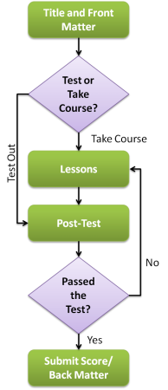

Figure 3.3 – Flowchart

**CHAPTER 4 : IMPLEMENTATION AND TESTING**

**4.1 Testing**

Testing is a crucial part of software development and ensures that the system works as expected, meeting requirements and providing a smooth user experience. In the context of your e-learning website, testing helps verify that all website features (e.g., registration, content viewing, quizzes) function properly, detect and fix bugs, improve usability, and maintain security.

**THE STEPS IN THE SOFTWARE TESTING**:

**1. Requirements Analysis:** Understand the specifications and requirements of the

educational website to determine the scope of testing.

**2. Test Planning:** Develop a comprehensive test plan outlining testing objectives, scope,

resources, schedule, and testing methodologies.

**3. Test Case Design:** Create test cases based on functional and non-functional

requirements, covering different scenarios, user interactions, and edge cases.

**4. Test Environment Setup**: Configure a testing environment that mirrors the

production environment to ensure realistic testing conditions.

**5. Unit Testing**: Verify individual components/modules of the educational website to

ensure they function as intended.

**6. Integration Testing:** Test the interaction between different components/modules to

identify and address any issues arising from their integration.

**7. System Testing:** Conduct end-to-end testing of the entire system to evaluate its

overall functionality, performance, and security.

**8. User Acceptance Testing (UAT):** Allow end-users or stakeholders to validate that the

educational website meets their expectations and requirements.

**9. Performance Testing:** Assess the system's responsiveness, scalability, and stability

under varying loads to ensure it can handle concurrent users.

**10. Security Testing:** Evaluate the website's security measures to identify and address

potential vulnerabilities, protecting against unauthorized access and data breaches.

**11. Compatibility Testing:** Ensure the website is compatible with different browsers,

devices, and operating systems to provide a consistent user experience.

**12. Usability Testing:** Evaluate the website's user interface and overall user experience

to ensure it is intuitive and user-friendly.

**13. Accessibility Testing:** Verify that the educational website complies with accessibility

standards, ensuring it can be used by individuals with disabilities.

**14. Regression Testing:** After each modification or update, re-run relevant tests to

ensure that existing functionalities have not been negatively impacted.

**15. Defect Reporting And Tracking:** Document and prioritize any issues or defects found

during testing and track their resolution.

**16. Documentation:** Maintain comprehensive documentation, including test plans, test

cases, and test results, to facilitate future testing efforts and system maintenance.

**17. Training:** Provide training to end-users or support teams on the proper usage of the

educational website and address any common issues that may arise.

**18. Continuous Improvement:** Gather feedback from testing phases and use it to

improve the development and testing processes for future releases.

**4.1.1 Unit Testing**

When unit testing an educational website, specific considerations and test cases can help

ensure the functionality, usability, and reliability of the platform.

Here are some items to include in unit testing for an educational website:

**1. User Authentication:**

* Test user registration and login processes.
* Verify password recovery/reset functionality.

**2. User Profiles:**

* Test profile creation and editing.
* Validate the display of user information.

**3. Course Management:**

* Test course creation, modification, and deletion.
* Ensure proper enrollment and unenrollment of students in courses.

**4. Content Delivery:**

* Test the display of educational content (text, images, videos, etc.).
* Verify proper functioning of multimedia elements.

**5. Assessments:**

* Test quizzes, exams, and other assessment tools.
* Check scoring and feedback mechanisms.

**6. Discussion Forums:**

* Test the creation and management of discussion forums.
* Ensure proper posting, editing, and deletion of forum threads and replies.

**7. Progress Tracking:**

* Validate the tracking of student progress within courses.
* Test the accuracy of completion status.

**8. Notifications:**

* Verify that users receive relevant notifications (e.g., announcements, reminders).
* Test the unsubscribe/opt-out functionality for notifications.

**9. Search Functionality:**

* Test the search feature for courses, content, and users.
* Ensure accurate and relevant search results.

**10. Responsive Design:**

* Test the website's responsiveness on various devices and screen sizes.
* Ensure usability on both desktop and mobile platforms.

**11. Security:**

* Verify that user data is securely stored and transmitted.

**12. Accessibility:**

* Check for compliance with accessibility standards (WCAG) to ensure the website is usable for all users, including those with disabilities.

**13. Browser Compatibility:**

* Test the website on different browsers (Chrome, Firefox, Safari, Edge) to ensure consistent performance.

**14. Performance:**

* Assess the website's loading times, especially for content-heavy pages.
* Test under various network conditions to ensure usability.

**15. Feedback Mechanisms:**

* Validate the effectiveness of feedback forms.
* Test error messages for clarity and helpfulness.

By Incorporating these elements into unit testing, you can identify and address issues early

in the development process, ensuring a reliable and user-friendly educational website.

**4.1.2 System Testing**

System testing for an educational website typically involves checking various components

and functionalities to ensure they work as intended. Some items to include in system testing

for an educational website are:

**1. User Registration And Authentication:**

* Verify that users can register successfully.
* Ensure secure authentication processes.

**2. User Interface (UI) Testing:**

* Check the overall design and layout.
* Test navigation and user interaction.

**3. Content Display:**

* Confirm that educational content is displayed correctly.
* Ensure multimedia elements (videos, images) work properly

**4. Course Enrollment And Management:**

* Test the process of enrolling in courses.
* Verify that users can access and manage enrolled courses.

**5. Assessment And Grading:**

* Test quizzes, exams, and assignments.
* Ensure accurate grading and feedback.

**6. Communication Features:**

* Verify messaging systems and discussion forums.
* Check notifications for announcements or updates.

**7. Search Functionality:**

* Confirm that the search feature works effectively.
* Ensure relevant results are displayed.

**8. Performance And Load Testing:**

* Test the website's performance under various loads.
* Check response times and server stability.

**9. Browser Compatibility:**

* Ensure the website functions correctly on different browsers.
* Verify compatibility with various devices.

**10. Security Testing:**

* Check for vulnerabilities and ensure data privacy.
* Test against common security threats.

**11. Accessibility Testing:**

* Verify that the website is accessible to users with disabilities.
* Ensure compliance with accessibility standards.

**12. Payment And Transaction Processing:**

* If applicable, test payment processes for paid courses.
* Confirm transaction security.

**13. Feedback And Reporting:**

* Test user feedback forms.
* Ensure reporting features are functional.

**14. System Integration:**

* Verify integration with other systems if applicable.
* Check for seamless data flow between components.

**15. Backup And Recovery:**

* Test backup and recovery mechanisms.
* Ensure data integrity and restoration processes.

**4.2 Test Cases**

**Test Case 1**: User Registration

**Test Case ID:** TC001

**Test Case Name:** User Registration

**Description:** Verify that a new user can register successfully with valid details.

**Preconditions**:User is on the registration page.

**Test Steps**:

1. Navigate to the registration page.
2. Enter valid details (name, email, password).
3. Click on the "Register" button.
4. Verify that the user is redirected to the dashboard or homepage.
5. Check that a confirmation email is sent to the provided email address.

**Expected Result**:

* User is successfully registered and redirected to the homepage.
* Confirmation email is sent.

**Actual Result**:

* Successfully registered.

**Status**: Pass

**Image Example** :  
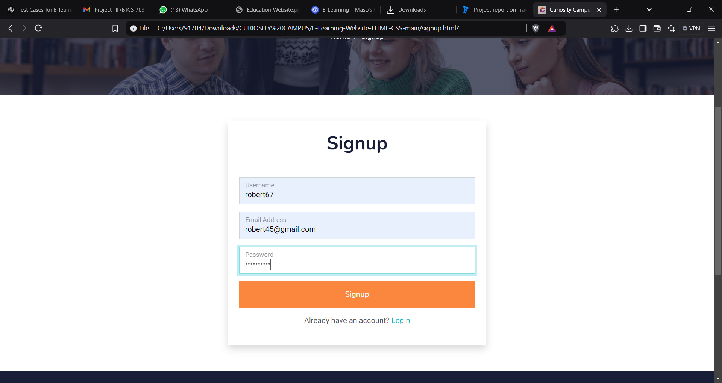

**Test Case 2: Search Functionality**

**Test Case ID:** TC002

**Test Case Name:** Search Functionality

**Description:** Verify that the search bar can find courses based on keywords.

**Preconditions:** User is on the course catalog page.

**Test Steps:**

1. Enter a keyword (e.g., "Java") in the search bar.
2. Click the "Search" button.
3. Verify that the search results display courses related to the keyword.

**Expected Result:**

* Courses related to the search term are displayed.

**Actual Result:**

* Courses displayed

**Status:** Pass

**Image Example :**  
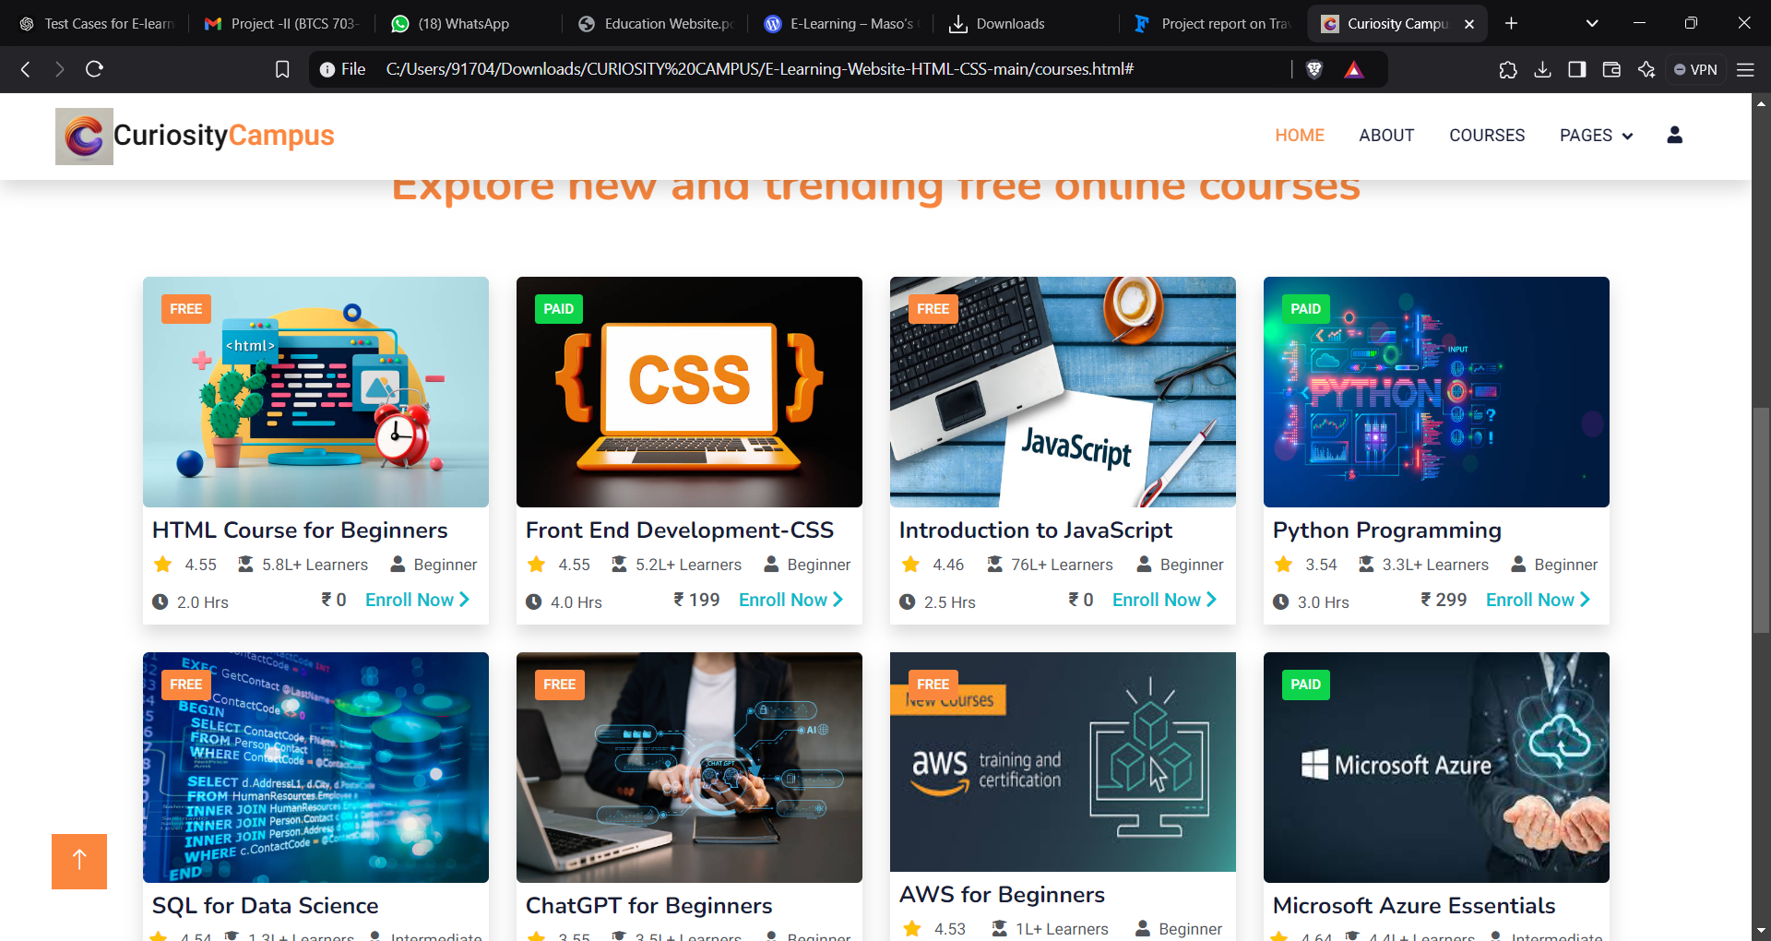

**4.3 Implementation and Challenges**

Implementing an e-learning website involves several stages, including planning, frontend and backend development, database management, testing, and deployment. Challenges can arise at each step. Scalability is essential as user numbers grow, which requires careful optimization of data retrieval, caching, and load balancing to prevent lag. Security is also crucial, demanding secure authentication protocols, data encryption, and frequent audits to protect user data. Additionally, creating a responsive design that works across devices while ensuring accessibility for all users is a priority. Another key challenge is handling media content, especially large videos, which need to be optimized to avoid long loading times. User engagement can be tough to maintain in a competitive landscape, so features like progress tracking, quizzes, and personalized recommendations can help. Consistent quality and relevance of content are essential, requiring regular updates based on user feedback. Thorough testing—both automated and manual—across functionality, usability, and performance helps deliver a stable platform that meets user needs and expectations.

One of the main challenges in the implementation is ensuring a seamless user experience across devices and browsers, requiring extensive testing and optimization for performance. Another challenge is implementing secure user authentication and data protection, as e-learning platforms store sensitive information like user credentials and payment details. Additionally, building a scalable system to accommodate a growing user base and integrating features like video streaming, quizzes, and real-time notifications adds complexity. Managing the consistency of course content, ensuring smooth integration with third-party tools, and troubleshooting bugs that arise from various devices and user scenarios are other obstacles that can make the implementation process time-consuming and complex. Despite these challenges, careful planning, attention to security, and thorough testing can lead to a robust, feature-rich platform that meets the needs of both learners and instructors.

**CHAPTER 5 : SNAPSHOTS**



Figure 5.1 – Home page

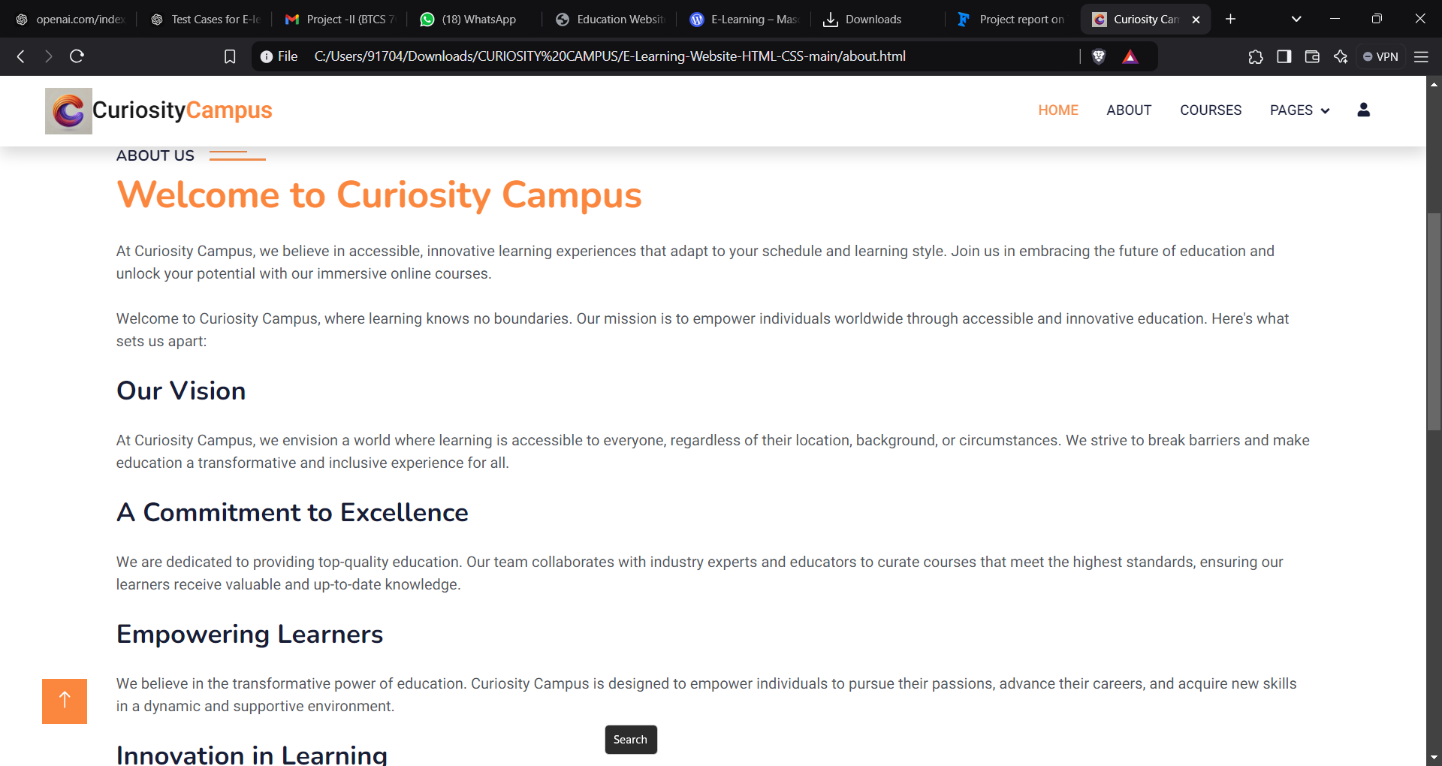

Figure 5.2 – About page

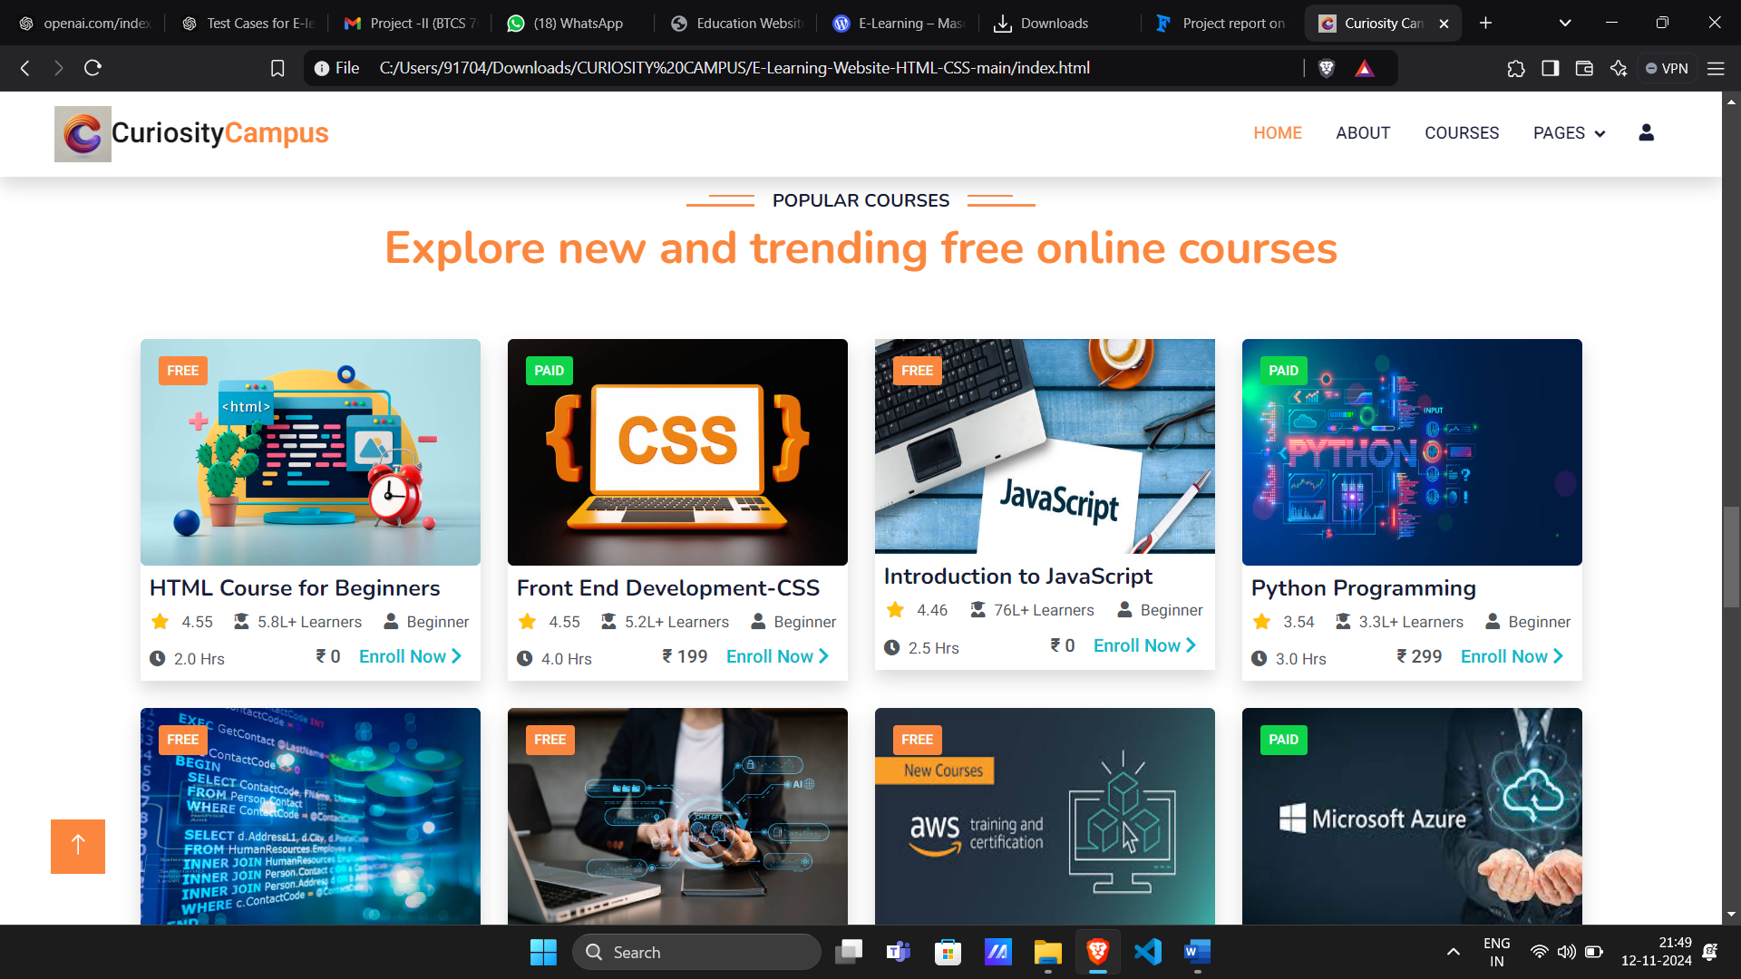

Figure 5.3 – Courses page

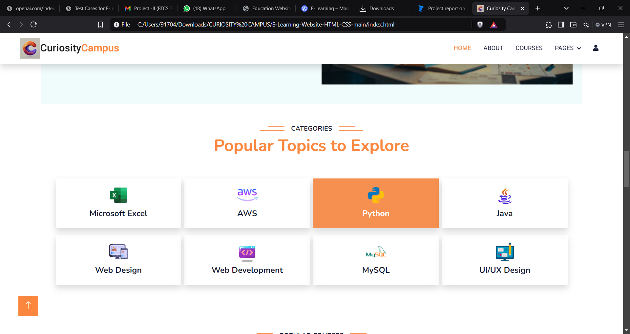

Figure 5.4 – Categories page

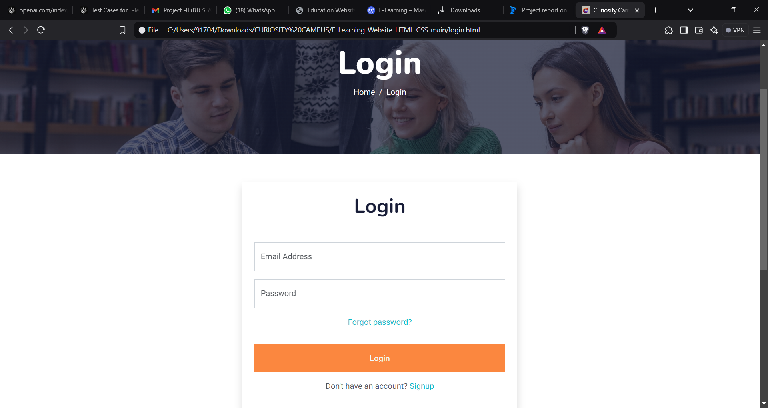

Figure 5.5 – Login page

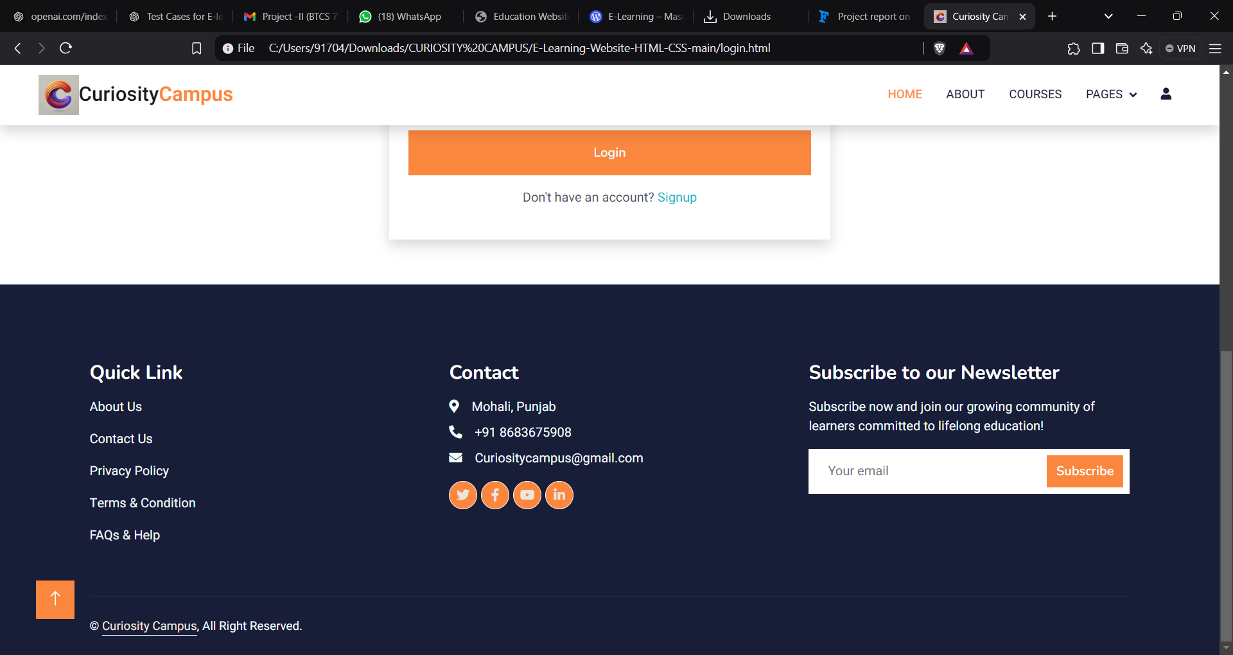

Figure 5.6 – Contact pag

**CHAPTER 6: FUTURE SCOPE**

We will improve it further. And we will put payment gateway init. We will provide daily quiz to the student Moreover, it is just a beginning; further the system may be utilized in various other types of auditing operation viz. Network auditing or similar process/workflow-based applications. This System being web-based and an undertaking of Cyber Security Division, needs to be thoroughly tested to find out any security gaps. A console for the data Centre may be made available to allow the personnel to monitor on the sites which were cleared for hosting during a particular period.

**6.1 Introduction**

System Security can be divided into four related issues:

●Security

●Integrity

●Privacy

●Confidentiality

**System Security** refers to the technical innovations and procedures applied to the hardwareand operation systems to protect against deliberate or accidental damage from a defined threat.

**Data Security** is the protection of data from loss, disclosure, modification and destruction 135 Docket Chunks System.

**Integrity** refers to the power functioning of hardware and programs, appropriate physical security and safety against external threats such as eavesdropping and wiretapping.

**Privacy** defines the rights of the user or organizations to determine what information they are willing to share with or accept from others and how the organization can be protected against unwelcome, unfair or excessive dissemination of information about it.

**Confidentiality** is a special status given to sensitive information in a database to minimize the possible invasion of privacy. It is an attribute of information that characterizes its need for protection.

**6.2 Security Software**

System security refers to various validations on data in form of checks and controls to avoid the system from failing. It is always important to ensure that only valid data is entered and only valid operations are performed on the system. The system employees two types of checks and controls:

**CHAPTER 7: CONCLUSIONS**

In the culmination of this educational website project, we arrive at a juncture that marks the realization of our initial vision and objectives. Over the course of its development, the website has evolved into a robust platform designed to address the unique needs of our target audience – be they students, educators, or administrators. This section serves as a comprehensive summary, encompassing the achievements, challenges, and impact of our endeavour. It is an opportunity to underscore the significance of the educational website in the broader context of modern education, acknowledging the strides made and laying the foundation for future enhancements. Join us in revisiting the key milestones and insights gained during this transformative venture.

**7.1 Summary Of Achievements:**

• Students get benefit of live classes with their mentors, with provide them a live interaction without hesitation. Every doubt of students gets easily solved.

• Provides many important links of exams and also the contents which is helps them to compete the exams.

• Provides them notes and sample papers for all the subjects. Students can download notes in their system without any problem.

• Daily quizzes are arranged for students. These quizzes daily get updated and they are built on google forms.

• Student can purchase course through completing the application form and payment then after verification from our side they get the invoice and daily email for live class link.

**7.2 Challenges And Solutions:**

We get challenge when we are trying to add the payment in application form. The payment Gateway is the mode which is used to transfer money online. Since it is the paid feature and we are students who are making a college project it is difficult for us to purchase that feature. To resolve that payment gateway problem, we get an idea of adding the UPI QR code of on which can get payment by clients. Then after we take their transaction id as input and in our database all their data get store including that transaction id. The transaction id we check and if it correctly matches with our transaction id then that client gets an email from us of invoice. If the transaction is wrong then we send them an email which says that again apply the form with the correct old transaction id if they had performed the transaction correctly if not then send the money once again.

**7.3 Benefits :**

**1.E- Learning Accommodates Everyone’s Needs**

The online method of learning is best suited for everyone. This digital revolution has led to remarkable changes in how the content is accessed, consumed, discussed, and shared. Online educational courses can be taken up by office goers and housewives too, at the time that suits them. Depending on their availability and comfort, many people choose to learn at weekends or evenings.

**2.Lectures Can Be Taken Any Number of Times**

Unlike classroom teaching, with online learning you can access the content an unlimited number of times. This is especially required at the time of revision when preparing for an exam. In traditional form of learning, if you cannot attend the lecture, then you have to prepare for that topic on your own; in eLearning, you can attend the lectures whenever you want with ease.

**3.Offers Access to Updated Content**

A prime benefit of learning online is that it makes sure that you are in synchronization with modern learners. This enables the learner to access updated content whenever they want it.

**4.Quick Delivery of Lessons**

eLearning is a way to provide quick delivery of lessons. As compared to traditional classroom teaching method, this mode has relatively quick delivery cycles. This indicates that the time required to learn is reduced to 25%-60% of what is required in traditional learning. There are some of the reasons why the learning time is reduced by eLearning:

* Lessons starts quickly and also wrapped up in a single learning session. This enables training programs to easily roll out within a few weeks, or sometime even days.
* Learners can define their own speed of learning instead of following the speed of the whole group.
* Saves time as a student does not need to travel to the training venue. You can learn at the comfort of your own place.

Students can choose to study specific and relevant areas of the learning material withoutfocusing on each and every area. For example, they can skip certain areas they do notwant to learn.

**5.Scalability**

eLearning helps in creating and communicating new training, policies, concepts, and ideas. Whether it is for formal education or entertainment, eLearning is very quick way of learning!

**6.Consistency**

eLearning enables educators to get a higher degree of coverage to communicate the message in a consistent way for their target audience. This ensures that all learners receive the same type of training with this learning mode.

**7.Reduced Costs**

eLearning is cost effective as compared to traditional forms of learning. The reason for this price reduction is because learning through this mode happens quickly and easily. A lot of training time is reduced with respect to trainers, travel, course materials, and accommodation. This cost effectiveness also helps in enhancing the profitability of an organization. Also, when you are studying at your own place, you are relieved from paying for travel expenses (e.g. accommodation) when training happens in another city/state and/or external learning materials.

**8.Effectiveness**

eLearning has a positive influence on an organization’s profitability. It makes it easy to grasp the content and digest it.

* It results in improved scores on certifications, tests, or other types of evaluation.
* Higher number of students who achieve ‘pass’ or mastery’ level.
* Enhanced ability to learn and implement the new processes or knowledge at the workplace.
* Help in retaining information for a longer time.

**9.Less Impact on Environment**

As eLearning is a paperless way of learning, it protects the environment to a lot of extent. As per a study done on eLearning courses, it has been found that distance-based learning programs consumed around 90% less power and generated 85% less amount of CO2 emissions as compared to traditional campus-based educational courses. With eLearning, there is no need to cut trees for obtaining paper. Thus, eLearning is a highly eco-friendly way of learning.

**CHAPTER 8 : REFERENCE**

**Website:**

[www.google.com](http://www.google.com)

[www.youtube.com](http://www.youtube.com)

[www.geeksforgeeks.com](http://www.geeksforgeeks.com)

[www.tech2etc.com](http://www.tech2etc.com)

Ware, P., & Warschauer, M. (2006). Electronic feedback and second language writing. In K Hyland and F.Hyland (Eds.) Feedback in second language writing: Contexts and issues (pp. 105-122). New York: Cambridge University Press. Warschauer, M. (1997). Computer-mediated collaborative learning: Theory and practice. Modern Language Journal,81, 470-481.

Aroyo, L., Dolog, P., Houben, G-J., Kravcik, M., Naeve, A., Nilsson, M., et al. (2006).Interoperability in Personalized Adaptive Learning. Journal of Educational Technology &Society,9 (2), 4 – 18.

Aydin, C.C., & Tirkes , G. (2010). Open-source learning management systems in e-learning and Moodle. In Proceedings of IEEE EDUCON 2010 - IEEE Engineering Education 2010, Madrid,14 16 April, 593 – 600